CS 255 System Design Document

UML Diagrams

UML Use Case Diagram

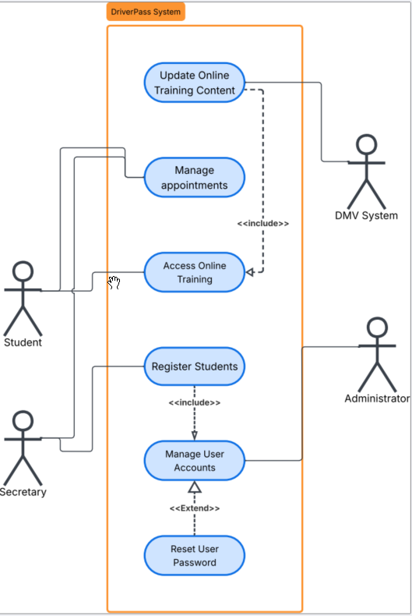
Figure 1- DriverPass System Use Case Diagram

UML Activity Diagrams

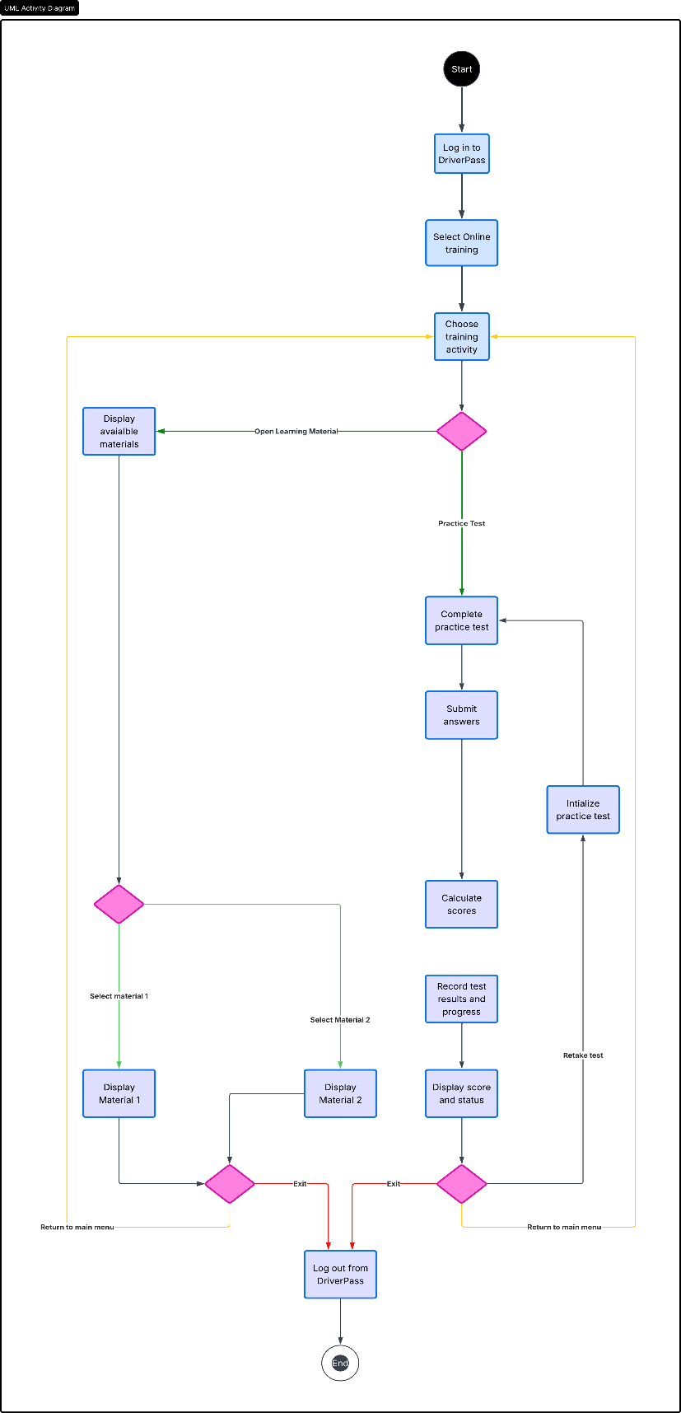
Figure 2 - UML Activity Diagram: Online Training
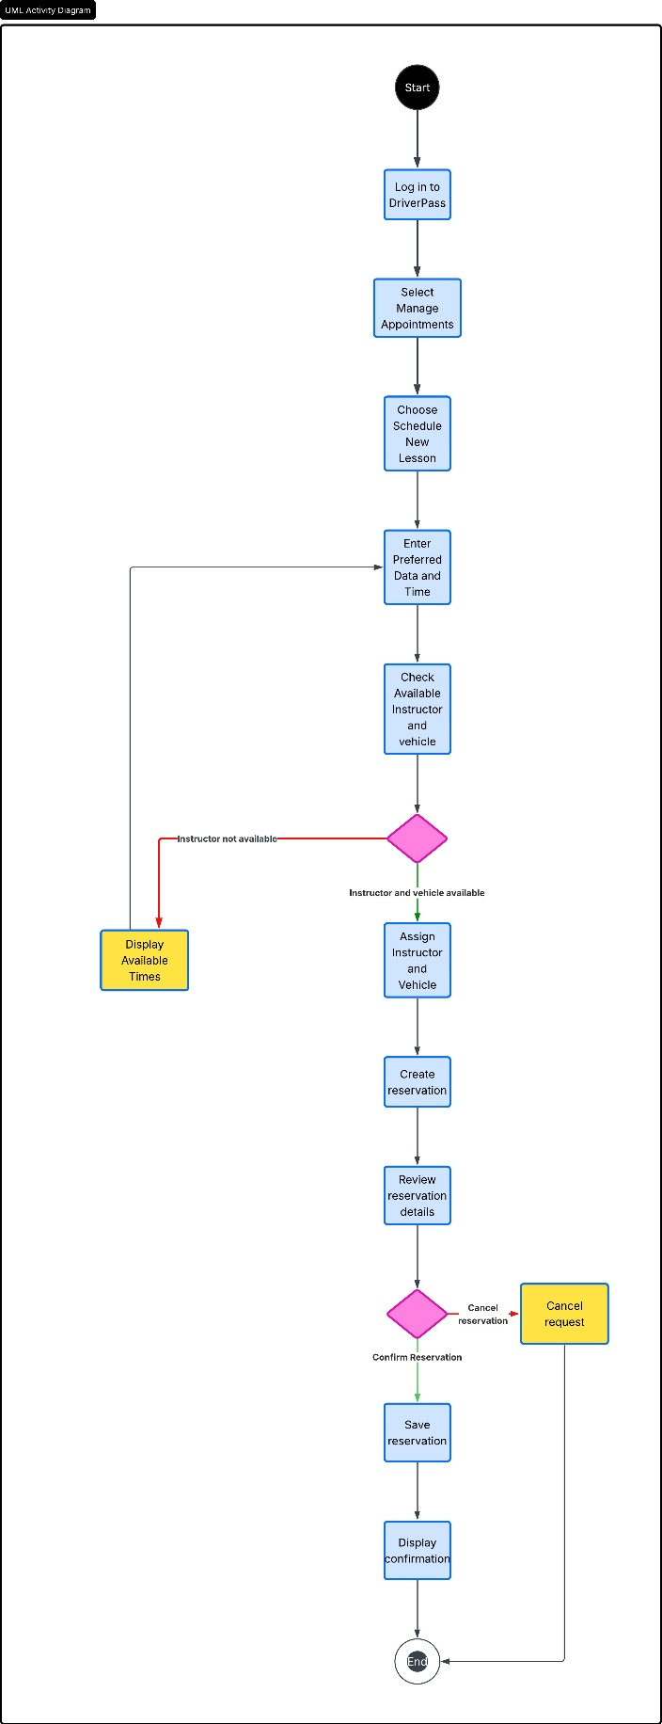
Figure 3 - UML Activity Diagram: Scheduling System

UML Sequence Diagram
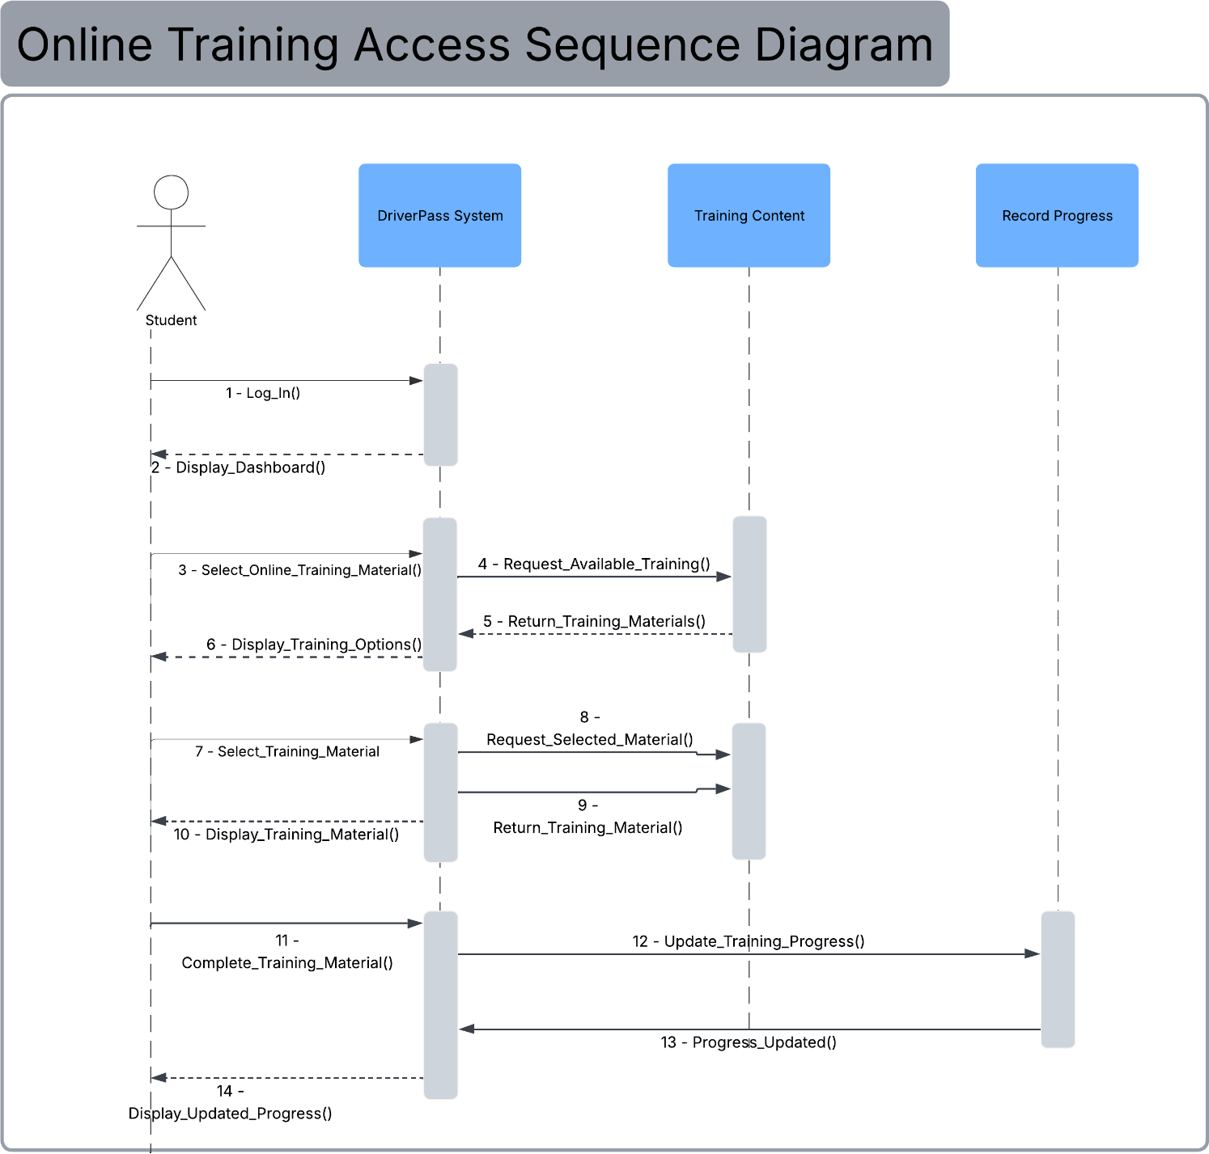
Figure 4 - UML Sequence Diagram: Online Training Access

UML Class Diagram
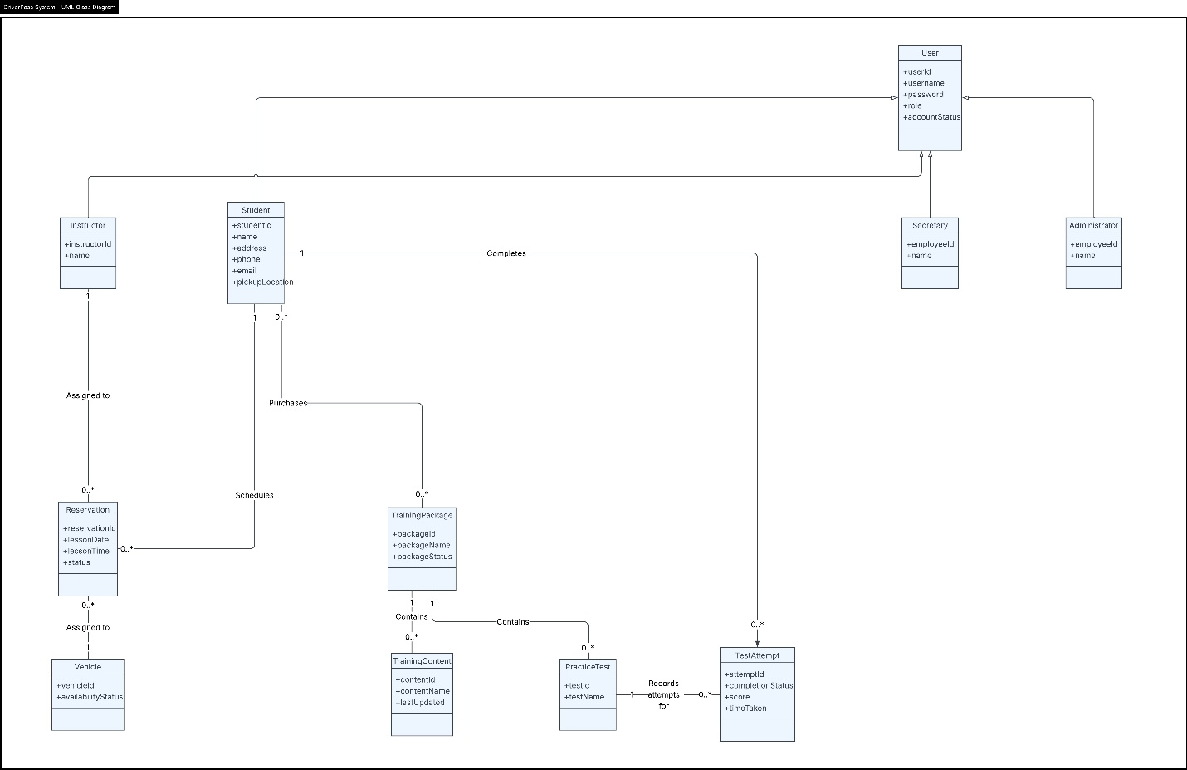
Figure 5 - UML Class Diagram: DriverPass System

Technical Requirements
DriverPass will require a cloud-based system that can be accessed through a standard web browser from desktop computers, laptops, tablets, and mobile devices. Since customers and employees need to access the system from different locations, the primary hardware requirement for users is an internet-connected device capable of running a modern web browser. DriverPass employees will also need reliable workstations and internet access to manage customer accounts, appointments, training packages, and reports. Because the system will be hosted in the cloud, DriverPass will not need to maintain its own on-site application servers.
The software will consist of a web-based application supported by a centralized database. The database will store customer and employee accounts, reservations, instructor and vehicle availability, training packages, practice-test results, and other information required by the system. The application must support the scheduling process shown in the system design by checking instructor and vehicle availability before creating a reservation. It must also provide access to online training materials and practice tests while recording student progress, test status, scores, and completion information. The system should work with commonly used web browsers and use a responsive interface so that the same services can be accessed from computers and mobile devices.
The infrastructure must provide reliable cloud hosting, database storage, backups, and secure communication between users and the DriverPass system. An internet connection will also be required to receive updated information from the DMV so that training materials and practice tests can remain current. Security controls must protect customer and business information through individual user accounts, password protection, secure transmission of information, and access permissions based on the user's role. Administrators, secretaries, instructors, and students should only be able to access the information and functions necessary for their responsibilities. The system should also maintain records of important user activity to support accountability and troubleshooting.
Development and maintenance will require tools for designing, building, testing, and updating the system. Lucidchart can be used to maintain the UML models that document the system's structure and workflows, while software development and database management tools will be needed to implement and maintain the web application. Testing tools should also be used to verify account access, scheduling conflicts, training functions, security controls, and compatibility across supported devices and browsers before updates are released. Together, these hardware, software, development tools, and cloud infrastructure requirements provide DriverPass with a system that can support its current services while allowing the business to maintain and expand the system as its needs change.

